Question 1:
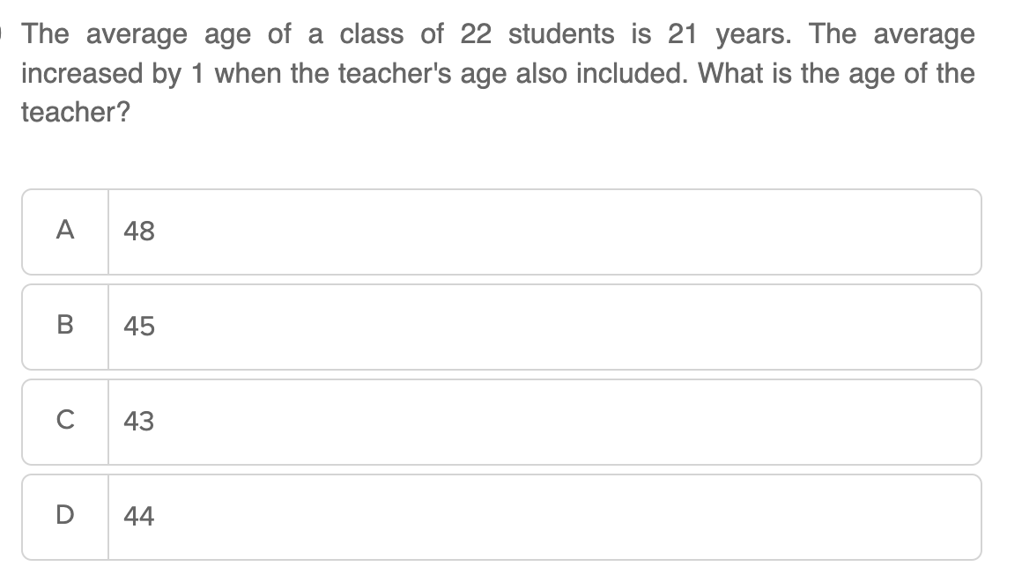

Question 2:
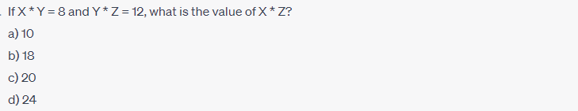

Question 3:
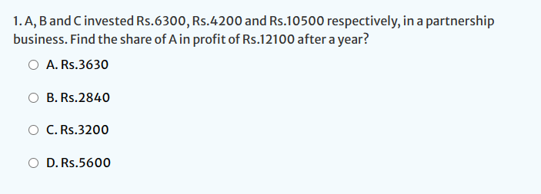

Question 4:
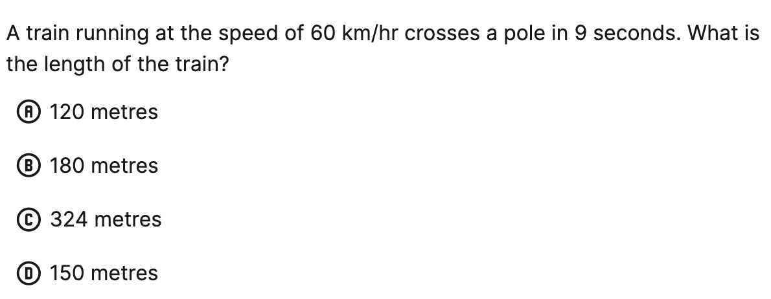

Question 5:
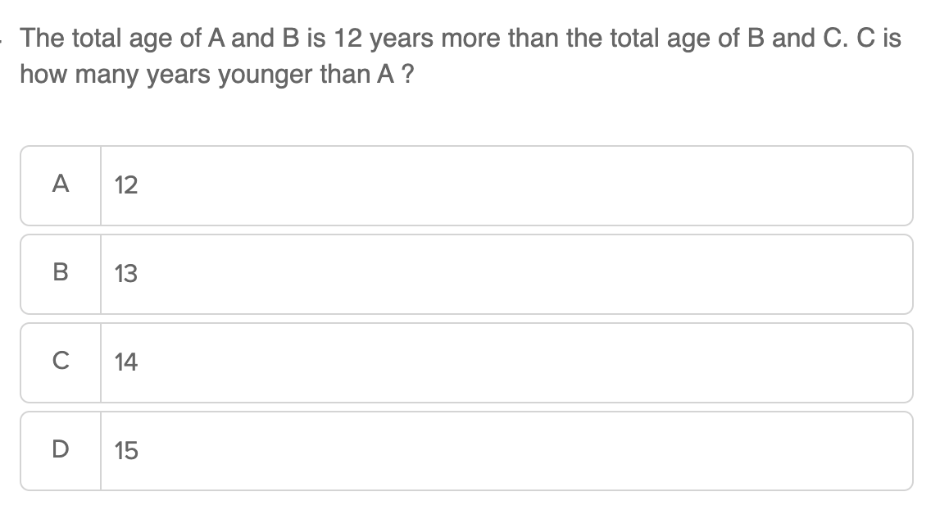

Question 6:
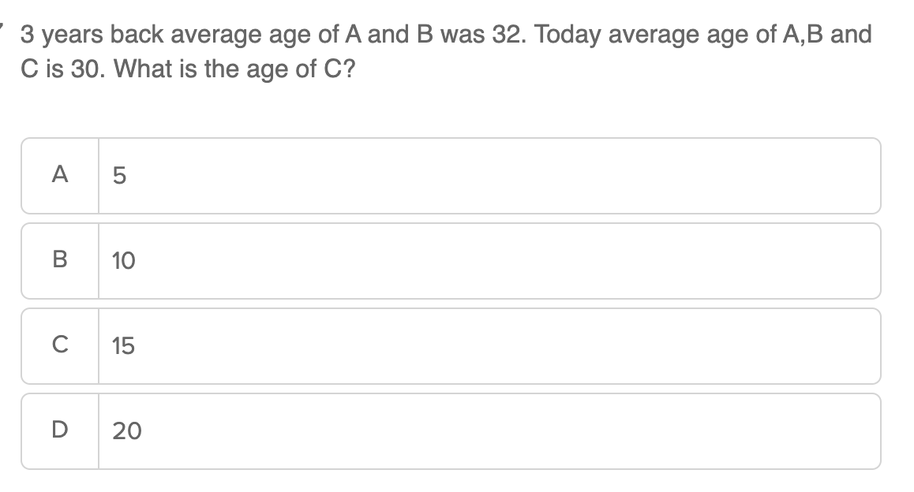

Question 7:
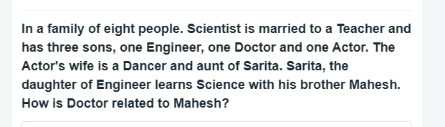


Question 8:
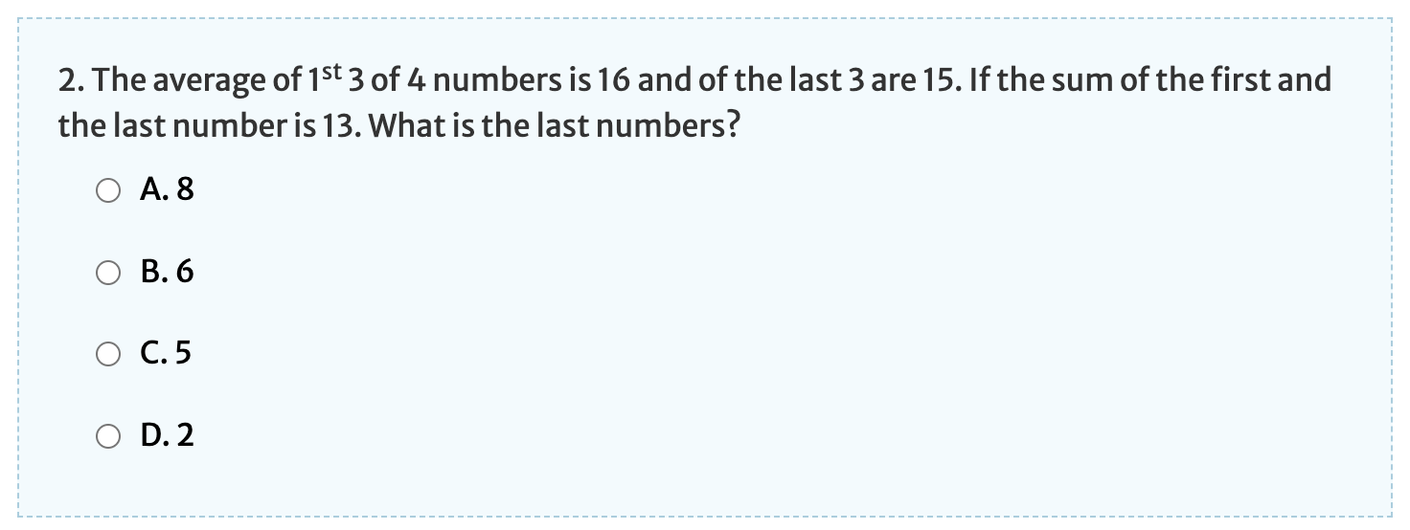

Question 9:
Avinash covers a distance of 8km in 50 minutes. If he covers 3km distance in 2/5th of time then, What speed should he maintain to cover the remaining distance in the remaining time?
- 13 kmph
- 14 kmph
- 10 kmph
- 15 kmph

Question 10:
